Enrollments / Case punchlist

Enrollment Reports

1. Relocate “Summary” table above other lines. So the vertical order is Group Title, Summary header and table, Period, Product, Method(s), Case Agents, and then (later) Products table  
   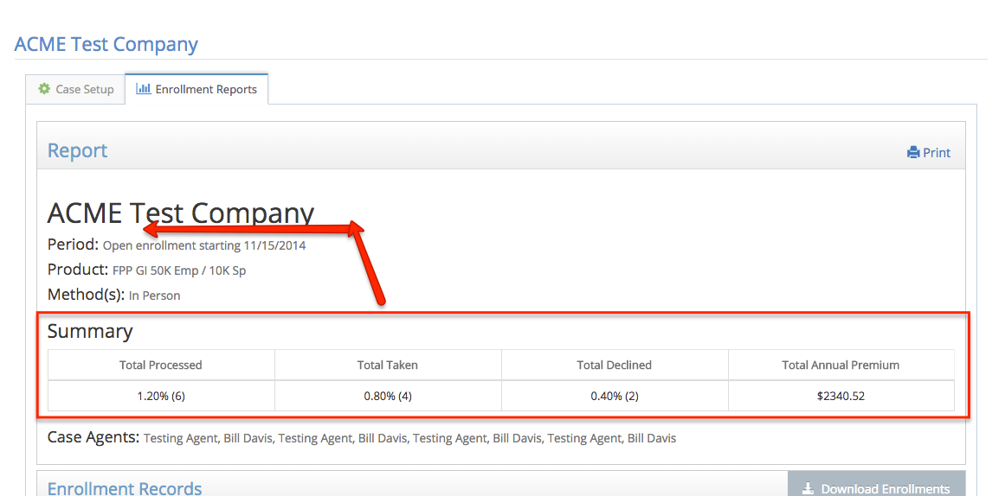
2. In “Total Processed” cell, add total number of records to parenthesis, as in  
   1.2% (6 of 500)
3. Add a new leading column, “Date/Time” with the date/time stamp (e.g., 01/27/15 15:41) – I think this is Signature Date in the file

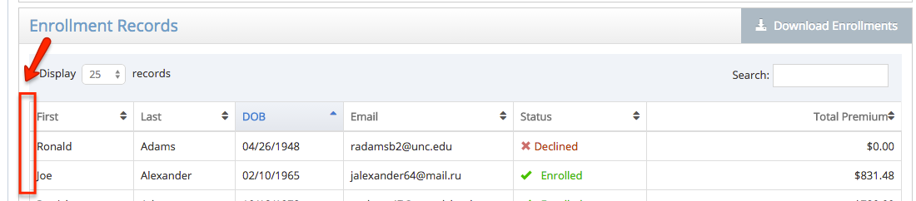

1. Download file
   1. Rename “Signature Date” header in file to be “Timestamp” and make it 1st column
   2. Make status second column
   3. Add fields
      1. Agent Code
      2. Agent Name
      3. Beneficiaries (all 4 fields)
2. BUG: Printing a report multiple time adds duplicate summary tables:  
   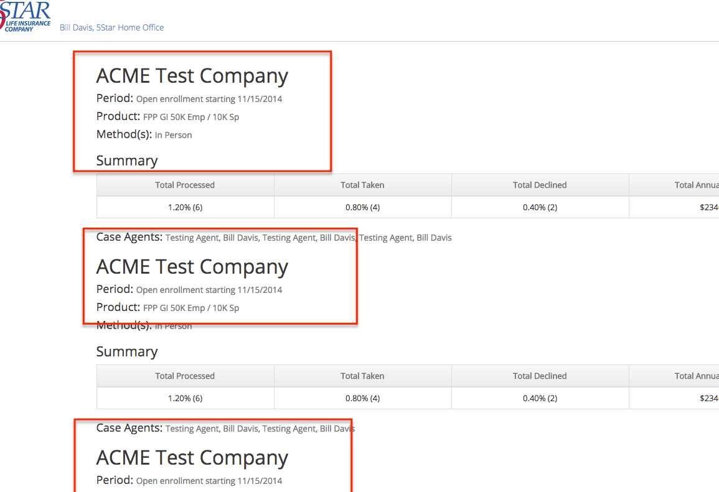
3. Can we easily just open the print target in a separate window? (or is that bad form?) Otherwise after printing the user is left on a static page with no navigation.
4. Allow Horizontal scroll on tables at <768px
5. Otherwise, would like mobile-friendly tables (perhaps for 2.5 release if there’s not a ready vehicle to do this):
   1. Breakpoints   
      I: <1024  
      II: <768w  
      III: <600w  
      IV: <560w  
      V: <480w
   2. Enrollment Records (on Enrollment Report)
      1. Default: Time, First, Last, DOB, email, status, premium
      2. At I: Time, First, Last, DOB, ~~email~~, status, premium
      3. At II: ~~Time,~~ First, Last, ~~DOB, email,~~ status, premium
      4. At V: ~~Time,~~ First, Last, ~~DOB, email, status~~, premium
   3. Case Census (on Case Setup)
      1. Default: First, Last, DOB, email, status
      2. At II: First, Last, DOB, ~~email,~~ status
      3. At IV: First, Last, ~~DOB, email,~~ status
      4. At V: First, Last~~, DOB, email, status~~
   4. Enrollment Table (on Enroll from Case)
      1. Default: button, Status, First, Last, DOB, email
      2. At III: button, Status, First, Last, DOB~~, email~~
      3. At IV: button, Status, ~~First,~~ Last, DOB~~, email~~
      4. At V we’ll rely on horiz scroll
6. Total Premium cell on enrollment records is $0 or else empty after overwriting one of the records? See email exchange with sample downloads Friday 1/30 circa 5:07pm

Case Setup

1. Tried to delete existing active case with an enrollment record (“123 Testco”), and got an error “There was a problem removing this case”. I assume this is because the case had active enrollments. Is there some other situation in which we would display this message? If not, let’s either hide the delete button such a case or else use this message:  
    *Cannot delete a case with posted enrollments. Instead mark the case as ‘inactive’.*  
   whichever is your UI preference.
2. BUG (minor, could be 2.5): I created a new GI product, added it to a Case and made the case active. Then before any enrollments on the case I deleted the GI product, which left the case in an Active state with no product defined. Should make such case inactive just as if removed product from UI.
3. (minor, could be 2.5) Is it easy to make a the open enrollment start date field not have to type in slashes for the date entry (as we don’t have to for the Annual Periods fields or even birthdate fields elsewhere)?

Home-Office

1. Setup GI product
   1. If used (selected for) any case, list in new section (same style header as “Guarantee Issue Criteria” and “When GI and criteria met”) at bottom (above Delete button) “Used in Cases”
   2. After “Save” button click, return to Manage Products screen
2. Header menu should always be Home, Agents, Products, Cases, Logout  
   - these pages appear to be incorrect
   1. edituser (Agents > click a name)
   2. All the Manage Cases pages (manage-cases, manage-case,

Enrollment Ad Hoc

1. BUG: “Product to Enroll” drop down should include all products to which I have visibility, a la the same as in Case Setup
2. BUG: went through whole ad-hoc FPP-TI enrollment and got error at end “Sorry, an error occurred communicating with the server.” – thinking this is perhaps related to turning Docusign API back on?
3. BUG: If I “Decline” an ad-hoc (doesn’t make much sense, but…) and click Next I get an error . Same/Related issue for bug #2 above?

Enrollment from Case

1. Enrollment main screen (6 buttons)
   1. Make a tool tip on “Enroll… via phone” that says “You are not authorized for call-center enrollment”
      1. While this will be universal for now, I expect to have it be a simple checkbox on the edituser screen (i.e., once we turn on call-center workflow, Home Office will designate who is authorized to enroll via a validated call center)
   2. Make a tool-tip on “Enroll…via email” that says “this feature coming soon!”
2. Enrolling ad-hoc not in census
   1. let’s revert to just check SSN and not DOB, too. More likely someone’s miskeyed a DOB (and we miss matching their SSN) than having a duplicate or miskeyed SSN.
      1. BTW, when I keyed in DOB as mmddyyyy the model just sat and spun on “Checking census for matches…” – I have to cancel out. But when I keyed in mm/dd/yyyy it found the record right away.  
         So, eventhough we’re eliminating the DOB let’s ensure what happens if we have bad data or a key not found.
   2. The new record should have “married” as false by default (it’s coming in as true)
3. BUG: Enrolling GI (e.g., “ACME Test Company”)… if I ask a GI knock out question, **but on a child**, then the child is simply eliminated unless the child is listed in the rules (which in this case they weren’t). Your error message shows:  
   *A "yes" response to this question prohibits this person from obtaining the selected $10,000 of coverage. You may proceed, however, by reducing your coverage to the guaranteed coverage amount of $-Infinity.*
4. BUG: Enrolling GI… if I “remove this applicant” when I hit a GI knock-out, then the resulting SOH headers/table is misaligned:   
   Before:  
   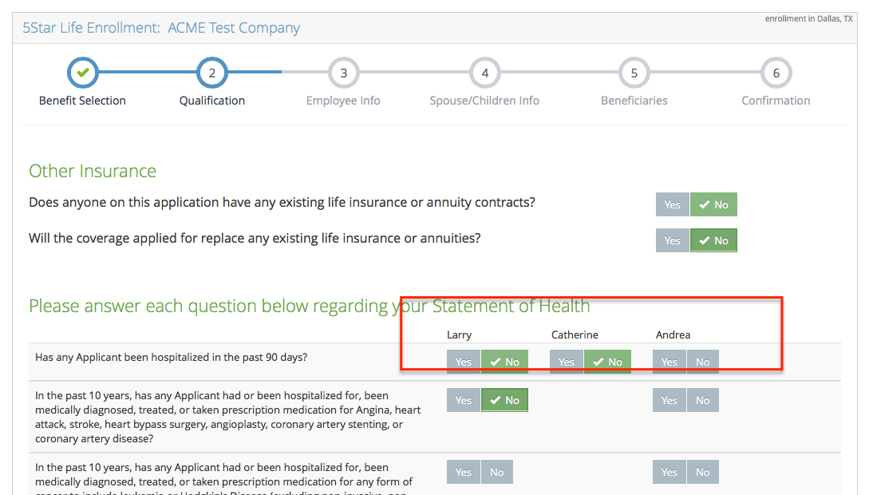  
     
   After eliminating EE:  
   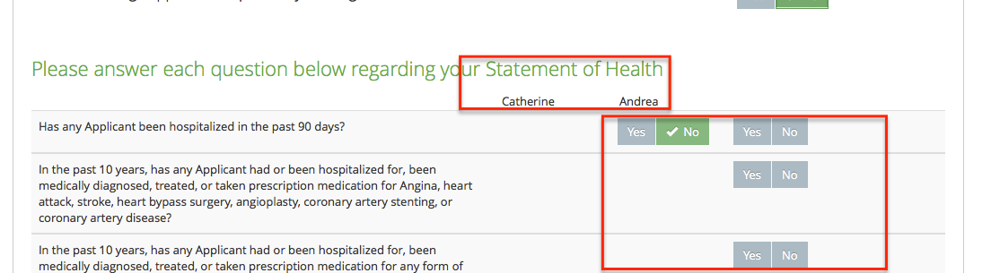
5. Post-signature/Enroll Next Applicant … can we eliminate the “flash” to the Enroll-from-Case screen and instead just go from the application-completed message page straight to the census page?
6. Re-Enroll (ok to push to 2.5)  
   Can we also pull in the “as enrolled” (i.e., that ‘merged record’) along with census… so we don’t have a “show rates” but show the selection table already as previously enrolled (but don’t repopulate the SOH questions – those have to be answered uniquely per compliance).
7. Enrolling GI (minor, OK to push to 2.5)… if I “remove this applicant” because of a “yes” GI knock-out so that effectively everyone is no benefit, we should return to step 1 in a “declined = true” state. As it is, they will merely continue forward with a $0 application, but we’d like to avoid that (especially in a self-serve mode). See related item #1 below under “Enrollment in general”.

Enrollment in general

1. SOH / step 2
   1. (push to 2.5 if not simple) when generally rejecting a “Yes” SOH question which results in a popup of “…disqualifies … proceed after removing that individual…”, can we also offer the same red & grey buttons as with GI, “Remove this applicant” and “Ignore and continue”   
      (caveat: if that’s the last applicant and you remove in Step 2, then have to return to step one with the state of “Declined” and “no benefits” selected)